Additional Notes for Professional Papers (APA 7)
GCS Graduate & EdD Programs

For professional papers, the following four sections are required:
- Title Page with Running Head
- Abstract with Keywords
- Body
- Reference List
Here are a few things to keep in mind as you format your paper:
- Font - 12-point Times New Roman.
- Spacing
  - Use only one space at the end of each sentence in the body of your paper.
  - In general, APA papers should be double spaced throughout.
  - To make sure that your paper is double spaced throughout, select the text, right click, select 'Paragraph,' and look under the section 'Line Spacing' as shown below:
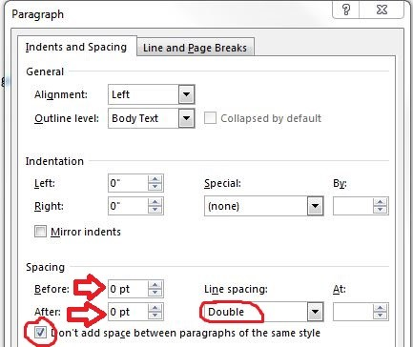
- Margins/Alignment - Your paper should use 1-inch margins on standard-sized paper (8.5' X 11'). Make sure that you use Align Left (CTRL + L) on the paper, except for the title page.
- Indentation – The first sentence in each new paragraph in the body of the paper should be indented a half inch. The abstract, however, should not be indented.
- Headings: Please note that all headings are in title case. Level 1 headings should be centered (and in bold), and Level 2 and 3 headings should be left-aligned (and in bold or bold italic, respectively). Level 4 and 5 headings are indented like regular paragraphs.
Title Page: When setting up the professional title page, please note the following elements should be present on the page:
- Title of paper (bolded and centered)
  - There is no limit to the number of words in the title.
  - Add an extra blank double-spaced line between the title and author’s name.
- Name of each author (centered)
- Name of department and institution/affiliation (centered)
- Author Note
  - Place the author note in the bottom half of the title page. Center and bold the label “Author Note.” Align the paragraphs of the author note to the left.
- Header, which includes:
  - Page number in top right corner of the header, starting with page 1 on the title page
  - Running head
    - The running head is an abbreviated version of the title of your paper (or the full title if the title is already short).
    - Type the running head in all-capital letters.
    - Ensure the running head is no more than 50 characters, including spaces and punctuation.
    - The running head appears in the same format on every page, including the first page.
    - Do not use the label “Running head:” before the running head.
    - Align the running head to the left margin of the page header, across from the right-aligned page number.
Abstract Page: The abstract page includes the abstract and related keywords.
The abstract is a brief but comprehensive summary of your paper. Here are guidelines for formatting the abstract:
- It should be the second page of a professional (graduate level) paper.
- The first line should say “Abstract” centered and in bold.
- The abstract should start one line below the section label.
- It should be a single paragraph and should not be indented.
- It should not exceed 250 words.
Keywords are used for indexing in databases and as search terms. Your keywords should capture the most important aspects of your paper in three to five words, phrases, or acronyms. Here are formatting guidelines:
- Label “Keywords” one line below the abstract, indented and in italics (not bolded).
- The keywords should be written on the same line as and one space after the label “Keywords”.
- The keywords should be lowercase (but capitalize proper nouns) and not italic or bold.
- Each keyword should be separated by a comma and a space and followed by a colon.
- There should be no ending punctuation.

