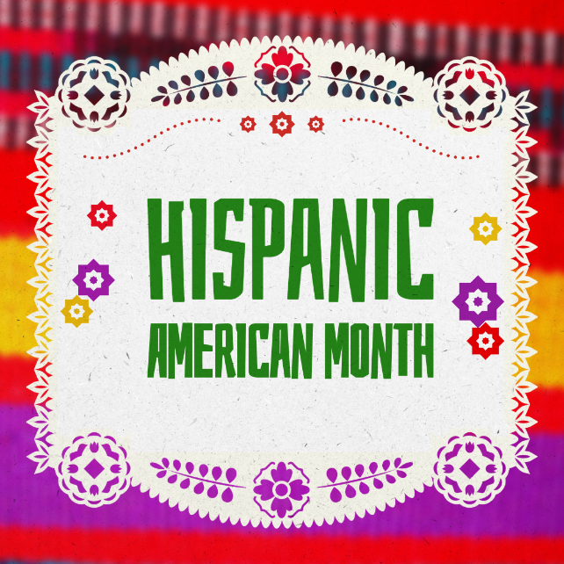

How to Borrow
- Find book on the shelf at Benner Library
- Check it out at Circulation Desk
- Use ONU Mobile Credentials as your library card

Selected print books recognizing Hispanic American Month
- Brown church: Five centuries of Latina/o social justice, theology, and identity (2020) by Robert Chao Romero | 3rd Floor Religion Room: 277.008968 R664b
- Just like us: The true story of four Mexican girls coming of age in America (2009) by Helen Thorpe | 3rd Floor: 305.86872 T398j
- Hispanic Americans (2007) by McCaffrey, Paul | 3rd Floor: 305.8968 H625m
- Mexicans in the making of America (2014) by Neil Foley | 3rd Floor: 973.046872 F699m
- My beloved world (2013) by Sotomayor, Sonia | 3rd Floor: 923.4 So78m
- Once I was you: A memoir of love and hate in a torn America (2020) by Maria Hinojosa | 3rd Floor: 070.92 H593o
- The Hispanic Republican: The shaping of an American political identity, from Nixon to Trump (2020) by Cadava, Geraldo L. | 3rd Floor: 324.2734089 C113h
- The story of Latinos and education in American history (2019) by Abdin Israel Noboa-Rios | 3rd Floor: 371.829 N669s

