Search Practice for Nursing
Purpose: to give you the tools and confidence you need to develop database search strategies
to efficiently access articles for your assignments…. So you can spend your time USING articles in your nursing assignments!
If you have questions on this assignment,
please contact Pam Greenlee, sgcslibrary@olivet.edu,
or 815-928-5439 (Interlibrary Loan)

Exercise # 1: Basic CINAHL Strategies
Prepare
- Go to the Library home page, https://library.olivet.edu.
- Follow these steps
  - Subject Guides
  - Nursing
  - Nursing Tutorials
- Watch the 3-minute CINAHL Basics Tutorial. A .pdf is also available if you prefer to read the instructions. Notice there are additional tutorials available.

Apply your Knowledge in the Database
From the Nursing Subject Guide page select CINAHL Compete.
- Search a topic of interest.
- Limit the date.
- Limit to peer review.
- Explore other limits on the left side bar.
- How do the number of results and their relevancy change as you search?

- Find the APA Citation.
  - Click on the title to get to the detailed record. Citation is on the lower right.
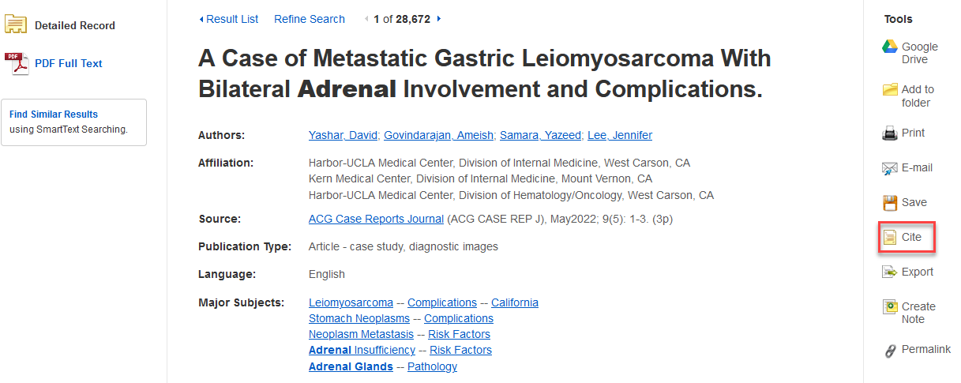

  - Copy the APA 7 Citation.
Yashar, D., Govindarajan, A., Samara, Y., & Lee, J. (2022). A case of metastatic gastric leiomyosarcoma with bilateral adrenal involvement and complications. ACG Case Reports Journal, 9(5), 1–3. https://doi.org/10.14309/crj.0000000000000764
  - Verify the citation format with your APA manual.
Tips
- Pay careful attention to capitalization, punctuation, italics.
- If no doi is given, use the “Find a doi” tool to search for one (to get these follow this path: https://library.olivet.eduHelpAPAFind a doi) . Usually, searching by the article title will retrieve the doi if there is one!

Exercise # 2: Find a primary research article
- Go back to the Nursing Tutorials on the Nursing Subject Guide page.
- Watch the Finding Research Literature tutorial.
- Locate a full-text research article dated within the last five years.
- Copy and paste the APA7 Citation and correct it.

Summing up
Answer the following questions:
- How do you know the article you selected is a research article? Tip: open either the abstract or the article. Look for “methods,” number of participants, and “results.”
- What research was done?
- With what population group?
- With what methods?
- Did the author actually collect and analyze new data? Is this article a summary of someone else’ research?
Additional Search Tips:
- Options on Advanced Search Page:
  - Research article limit (on Advanced search page)
  - Nurse Author
- Limit Options:
  - Peer Reviewed
  - Date
- Subject: Major Heading (show more) Is there an idea that appeals to you?

Access tip:
If you need an item that is not available in full text, use the “REQUEST THIS ITEM (ILL)” icon/link in the database. Staff from Benner Library’s Interlibrary Loan department will get the article from a partner library and email it to you. This is a free service and you can keep the article forever!

Need more help?
Ask a Librarian
- https://library.olivet.edu/contact/ask-a-librarian.php
- 815-939-5355
- SGCSLibrary@olivet.edu

Updated August 18, 2022 by PG

